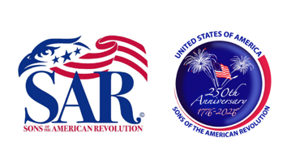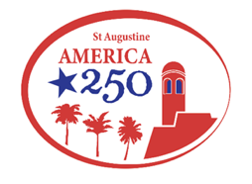
www.libertytreesar.org www.america250staugfl.org

ST AUGUSTINE CHAPTER – THE LIBERTY TREE CHAPTER

UPCOMING EVENTS 2025-2026
11 September 9/11 Remembrance, SAFD Station, 101 Malaga St, 8:30 am
17 September Constitution Day Bells Across America, Plaza de la Constitution, 4 pm
21 September POW/MIA Remembrance Ceremony, Cecil Field, JAX
17-18 October Fall BOM, Kissimmee FL
11 November Veterans Day
11 November SAR Speaker – Captain Bob Buehn – Guantanamo Bay
12-16 November SAR Trip to South Carolina/SC Annual Rev War Symposium (15th)
27 November Thanksgiving
18 November SAR Speaker – Rick MacAlister – Tunnel Rat Vietnam
13 December SAR Speaker – Charlie Hayes – Induction of Officers
25 December Christmas
1 January New Years Day
8 January Colonial Dames Speaker, Dale Cox
“The Impact of Indigenous Peoples in Florida on the American Revolution”
10 January SAR Speaker - RJ Larizza – State Attorney for Daytona
12 February Colonial Dames Speakers: Jane Landers, Vanderbilt University & Gigi Best-Richardson.
“What Part Did Florida Africans Play in the American Revolution?”
13 February SAR Speaker – Becky Dove – Museums & Museum Management
28 February Putnam Co. Liberty Tree Dedication
14 March SAR Speaker – Dr. Chip Gragg – Author: Patriots in Exile
14 March Pompano Beach Marine Amphib Marker Dedication
21 March Last Naval Battle – CHECK THIS DATE
26 March Colonial Dames Speakers: Tom Hand, Americana Corner & Jeff Jore, Flagler College
“We Floridians Could Have Been British If It Weren’t for the Spanish!”
28 March Thomas Creek
2 April Colonial Dames Speakers: Greg Holbrook, New Smyrna History Museum, & Dr. Darien
Andreu, Flagler College
“1777 Flight To Freedom for the Minorcans of New Smyrna”
11 April SAR Speaker – Christopher Washler – FLSSAR President
11 April FLSSAR President Chris Washler Visit St Aug Chapter
25 April 2nd Annual Liberty Tree Golf Tournament, Palatka Golf Course. 9:00 a.m.
8 May Siege and Battle of Pensacola
19 May SAR Speaker – Robert Covert – St Augustine Historical Society
7-11 May St. Augustine History Festival (SAR George Washington Tent 10th? Reconfirm)
21 May Colonial Dames Speakers: Chuck Meide, LAMP, & Jay Smith, Lighthouse
“British Loyalists and American Patriots in St. Augustine”
25 May Memorial Day Ceremony, National Cemetery, 10 am
14 June Flag Day, Meet with DAR at St Aug downtown parking garage
27 June Alligator Creek Battle Commemoration, Calahan, FL
4 July Independence Day
12 July 135th NSSAR Congress
11 August SAYC Reenactment of the Declaration of Independence Delivery to St Augustine
15 August Seminole War Commemoration, National Cemetery, 10 am
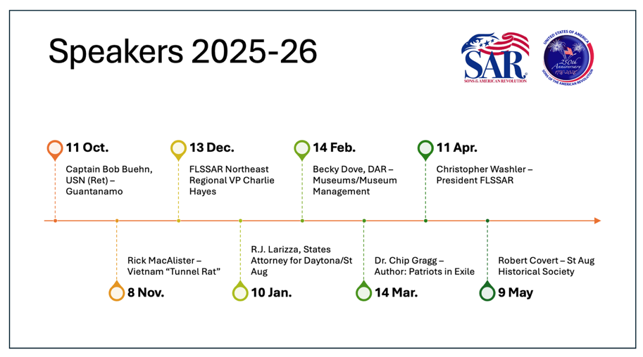
St Augustine SAR Meetings and Speakers 2025-2026

